Type: Internal Email

FTTP_F2_DESIGN; A0294B2; POLRGAMA; SOUTH-FL; 110203; HOA RESEARCH

To: Margret Kasem

CC: Demis, Idel & Leo

Margret,

The subject line CFAS requires HOA validation prior to the F2 LG design.

Please see the info and screenshot below and advise if more information is needed.

An IWM entry is also needed.

HOA found: XXX

HOA name: XXX

PFP Address: XXX

HOA Contact name: XXX

HOA Contact email: XXX

HOA Contact Number: XXX

**{Please attach a screenshot of the area. If multiple HOA’s please note and mark where they are}**

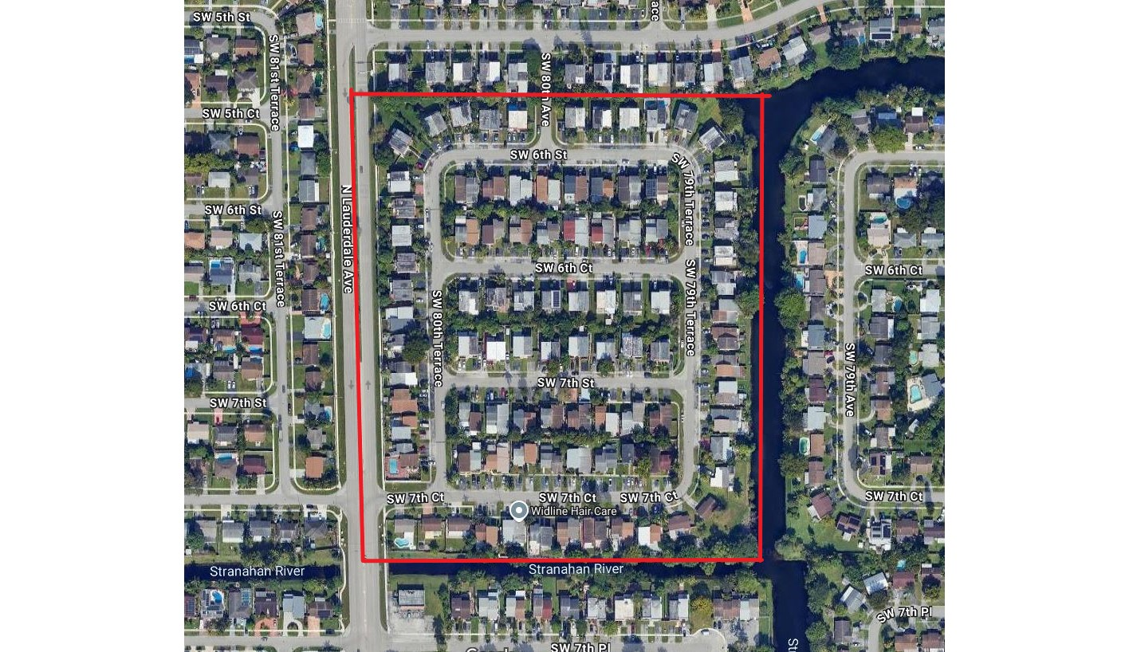

**Note to designers:**

**Please follow up on this request as much as possible.**

**An IWM entry is needed for every project upfront when an HOA is found. AT&T monitors these entries to gauge our progress.**